ORDER OF WORSHIP
* Indicates, please stand if able.
Second Sunday after Pentecost June 11, 2023 9 am
Liturgist: Roxie Hostrawser

WELCOME, PASSING THE PEACE OF CHRIST, & ANNOUNCEMENTS
*CALL TO WORSHIP
L: The Lord seeks a relationship with you.
P: Lord, we long to know you more.
L: The Lord wants you to know and follow His commands.
P: Lord, we want to know you more.
L: The Lord wants to hear from you.
A: Help us to pray and seek your face always.

*OPENING PRAYER
Most heavenly father. We come before you today hoping to get a better glimpse of you and your statutes. We want to be sure that we will go to heaven. We want to know that our actions, our words, and even our thoughts are acceptable to you. We ask that you give us insight to all of your words and commands. Let us see all things through your eyes, and not just through our eyes only. Help us to read, and pray and seek you always, in bad times, but especially good times as well. We ask this in the precious name of Jesus Christ our Savior. AMEN.

*OPENING HYMN Spirit of the Living God UMH #393
JOYS AND CONCERNS
PRAYER OF CONFESSION
Lord, have mercy on us your children. We long to know you more, but we often get so busy that we make the excuse that we don’t have time to read, we don’t have time to pray and we don’t have time to seek you. After all, when things go well, we often believe that we don’t need you. Forgive us of that backwards thinking, and help us to know that we need you always. Show us the importance of prayer, and the importance of knowing your laws and your word, (the bible). Help us to change from faithless beings to Spirit filled Christians living by your word daily. We ask all of this in Jesus’ name. AMEN.

WORDS OF ASSURANCE (2 Chronicles 7:14)
If my people, which are called by my name, shall humble themselves, and pray, and seek my face, and turn from their wicked ways; then will I hear from heaven, and will forgive their sin, and will heal their land.
PASTORAL PRAYER Daniel Brauner
THE LORD’S PRAYER (In Unison)
Our Father, who art in heaven, hallowed be thy name. Thy kingdom come, thy will be done on earth as it is in heaven. Give us this day our daily bread. And forgive us our trespasses, as we forgive those who trespass against us. And lead us not into temptation, but deliver us from evil. For thine is the kingdom, and the power, and the glory, forever. Amen.
INVITATION TO THE OFFERING (2 Corinthians 9:11)
You will be enriched in every way so that you can be generous on every occasion, and through us your generosity will result in thanksgiving to God.”
*DOXOLOGY Praise God, from Whom All Blessings Flow UMH #95
*OFFERTORY PRAYER (Genesis 12)
God of Abraham and Sarah, you bless our lives, that we might be a blessing to others. May the offering we bring before you this day be a sign of our commitment to bless the world in your name. We send forth these gifts, that they may be instruments of your circle of grace and faith. Amen.
SCRIPTURE Colossians 2:6-7
⁶ So then, just as you received Christ Jesus as Lord, continue to live your lives in him, ⁷ rooted and built up in him, strengthened in the faith as you were taught, and overflowing with thankfulness.
Proverbs 3:5-7
⁵ Trust in the Lord with all your heart, and lean not on your own understanding;
⁶ in all your ways submit to him, and he will make your paths straight. ⁷ Do not be wise in your own eyes; fear the Lord and shun evil.
Proverbs 9:9-12
⁹ Instruct the wise and they will be wiser still; teach the righteous and they will add to their learning. ¹⁰ The fear of the Lord is the beginning of wisdom, and knowledge of the Holy One is understanding. ¹¹ For through wisdom your days will be many, and years will be added to your life. ¹² If you are wise, your wisdom will reward you; if you are a mocker, you alone will suffer.

*HYMN OF PRAISE Breathe on Me Breath of God UMH #420

MESSAGE Are We Rooted in Christ Daniel Brauner
*CLOSING HYMN Time to be Holy UMH #395

*BENEDICTION
L: Stand tall and walk in Christ’s peace.
P: Speak up and tell of God’s goodness.
L: Touch and heal with the Spirit’s love, today and always. Amen.
POSTLUDE Matt Schluntz

ANNOUNCEMENTS

RADIO BRAODCAST: Last Sunday's radio broadcasting was offered by Daniel Brauner in
honor of Edward and Vione Brauner's 70th anniversary.
PRAYER REQUESTS: Please pray for people in need in our church, community, nation,
and the World.
ANNUAL CONFERENCE: June 9-12, at KI Center, Green Bay.
SCRIP CARDS: When you are thinking of ideas for gift giving or personal use, consider
Scrip cards. Stop at the gathering area on Sundays or call Marcia at 715-284-3346
USHER/GREETERS: Jim Bible and Imelda Kelly

This month at the Church:
Mon, June 12 Board of Trustees 5:00 pm
Tue, June 13 Ad Council 6:30 pm
Mon, June 19 Finance Committee 5:30 pm
Tue, June 20 Worship Committee 5:30 pm

Bible Verse for the week: Proverbs 3:5-7
⁵ Trust in the Lord with all your heart, and lean not on your own understanding; ⁶ in all your ways submit to him, and he will make your paths straight. ⁷ Do not be wise in your own eyes; fear the Lord and shun evil.

Black River Falls
United Methodist Church

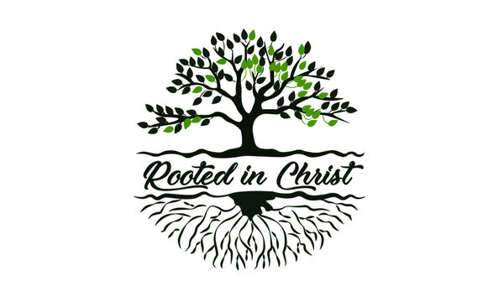

UMC Mission Statement:
"To make disciples of Jesus Christ for the transformation of the world.”

PASTOR Rev. Inwha Shon
PIANIST Matthew Schluntz
MUSIC DIRECTOR Amanda Lang

100 North Fourth Street, Black River Falls, WI. 54615
Phone: 715-284-4114 Office Hours: Monday-Thursday, 9 am-2 pm
Website: brfumc.org & Black River Falls United Methodist Church Facebook
brfumc at YouTube

